TUTORIAL / PRACTICAL – 8
BUGZILLA & TESTLINK

Practical No.: 8
Tester Name: Janvi Patel
Tools: Bugzilla and TestLink
Environment: Windows 11, Google Chrome

TC-001
Module: Login
Scenario: Valid login
Test Steps: Open login; enter valid username/password; click Login.
Test Input: janvi / abc12345
Expected Result: Login should succeed.
Actual Result: Login Successful!
Status: PASS
Comment: Valid credentials.
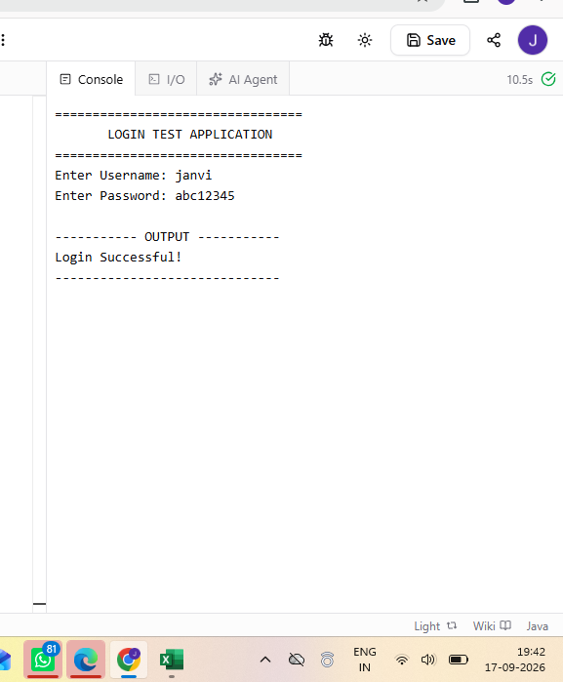
TC-002
Module: Login
Scenario: Invalid password
Test Steps: Open login; enter valid username; enter wrong password; click Login.
Test Input: janvi / wrong123
Expected Result: System should reject credentials.
Actual Result: Invalid Username or Password.
Status: PASS
Comment: Invalid credential handling.
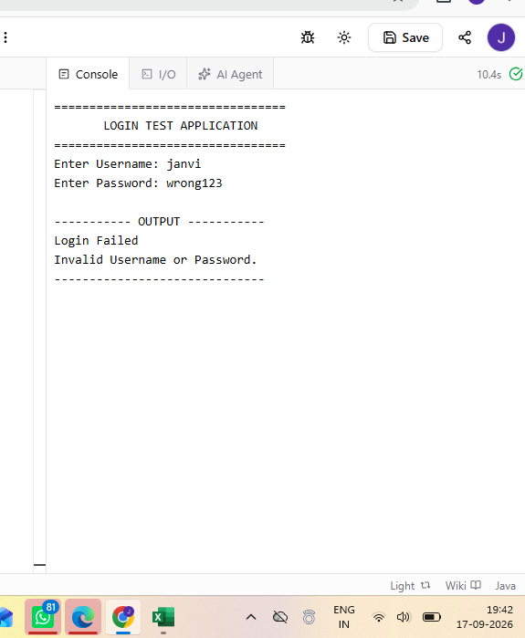

TC-003
Module: Login
Scenario: Blank username
Test Steps: Open login; leave username blank; enter valid password; click Login.
Test Input: Blank / abc12345
Expected Result: Blank username should be rejected.
Actual Result: Invalid Username or Password.
Status: PASS
Comment: Blank username handled.
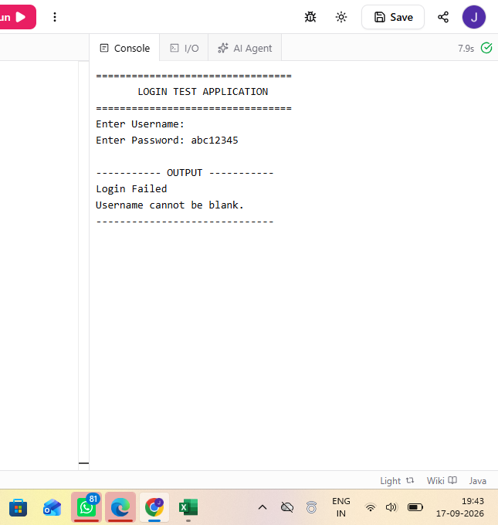

TC-004
Module: Login
Scenario: Blank password
Test Steps: Open login; enter username; leave password blank; click Login.
Test Input: janvi / Blank
Expected Result: Specific password-required message should appear.
Actual Result: Invalid Username or Password.
Status: FAIL
Comment: BUG-001: blank-password validation missing.
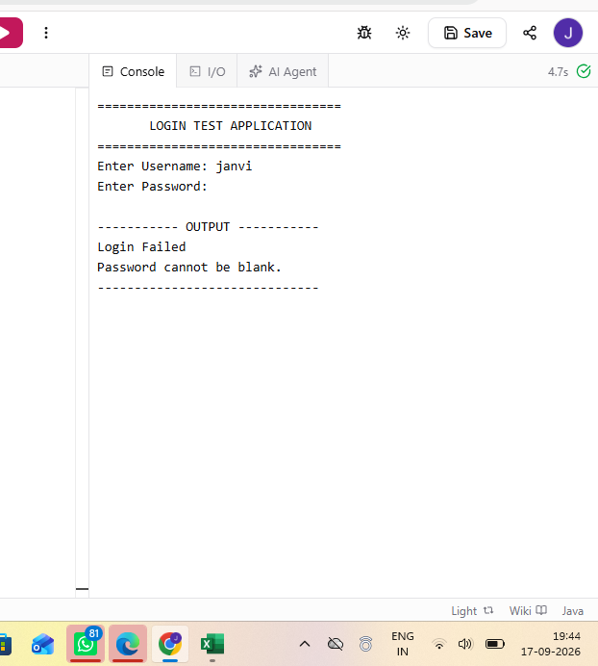
TC-005
Module: Registration
Scenario: Weak password
Test Steps: Open registration; enter username/email; enter weak password; submit.
Test Input: user1 / user@test.com / 12345
Expected Result: Weak password should be rejected.
Actual Result: Weak password is accepted.
Status: FAIL
Comment: BUG-002: weak password accepted.
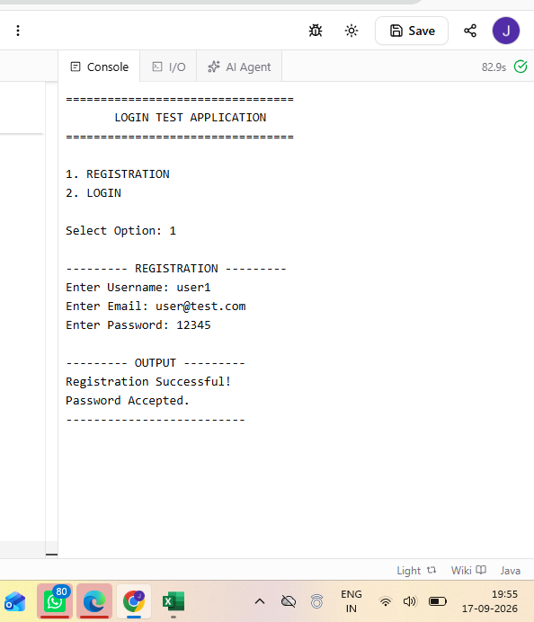
TC-006
Module: Registration
Scenario: Valid registration
Test Steps: Open registration; enter valid details; submit.
Test Input: user1 / user@test.com / Strong123
Expected Result: Registration should succeed.
Actual Result: Registration Successful!
Status: PASS
Comment: Normal registration.
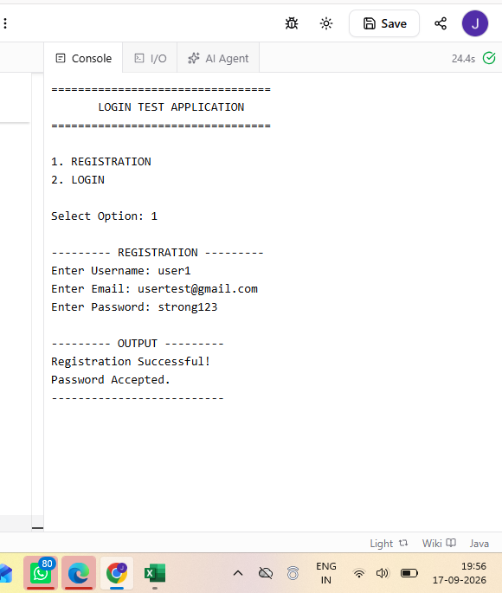

TC-007
Module: Payment
Scenario: Payment page response
Test Steps: Open payment; enter valid details; proceed; observe loading.
Test Input: Valid payment details
Expected Result: Page should respond within acceptable time.
Actual Result: Payment page takes noticeably longer to load.
Status: FAIL
Comment: BUG-003: performance issue.
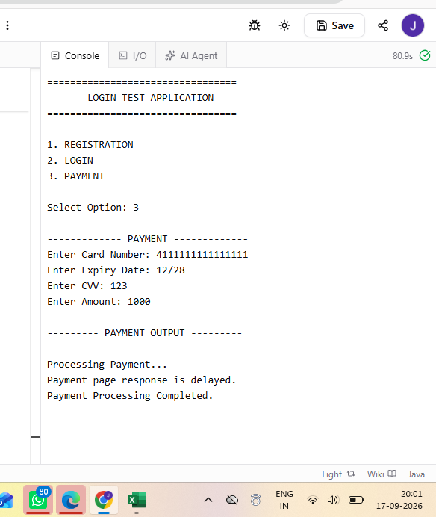
TC-008
Module: Payment
Scenario: Payment processing response
Test Steps: Open payment; enter valid information; proceed; observe response.
Test Input: Valid payment details
Expected Result: Processing should respond normally.
Actual Result: Payment page responds slowly.
Status: FAIL
Comment: BUG-003 reproduced.
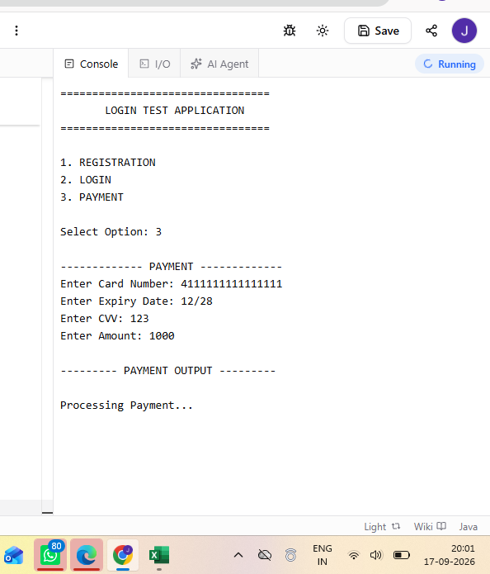
TC-009
Module: Bugzilla
Scenario: Create defect
Test Steps: Log in; select product/component; enter summary/description; submit.
Test Input: BUG-001 summary
Expected Result: Bug should be created with Bug ID.
Actual Result: Bug record created successfully.
Status: PASS
Comment: Defect creation workflow.
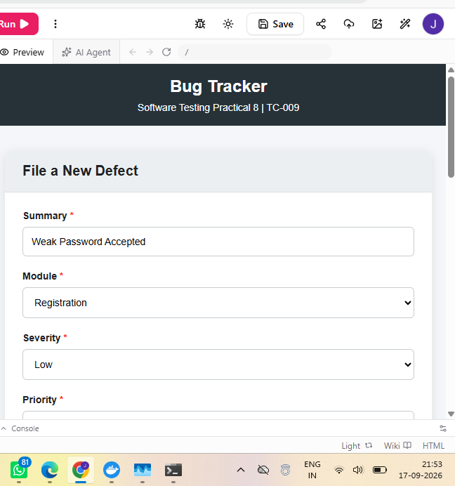

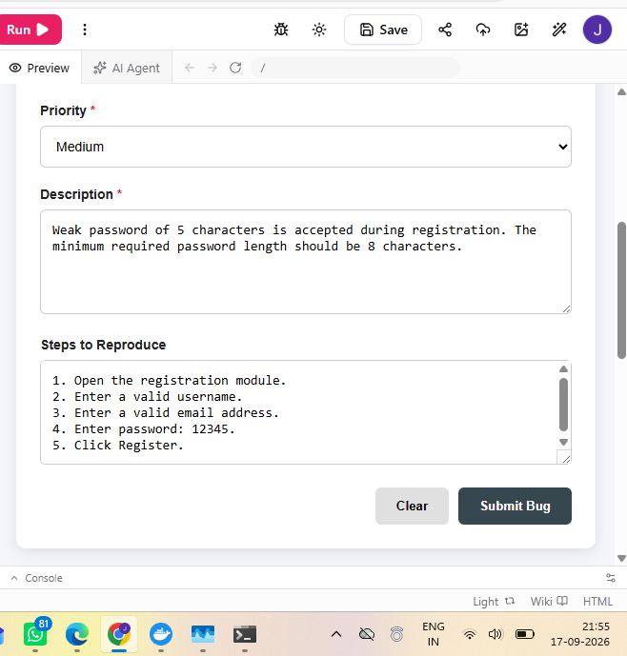
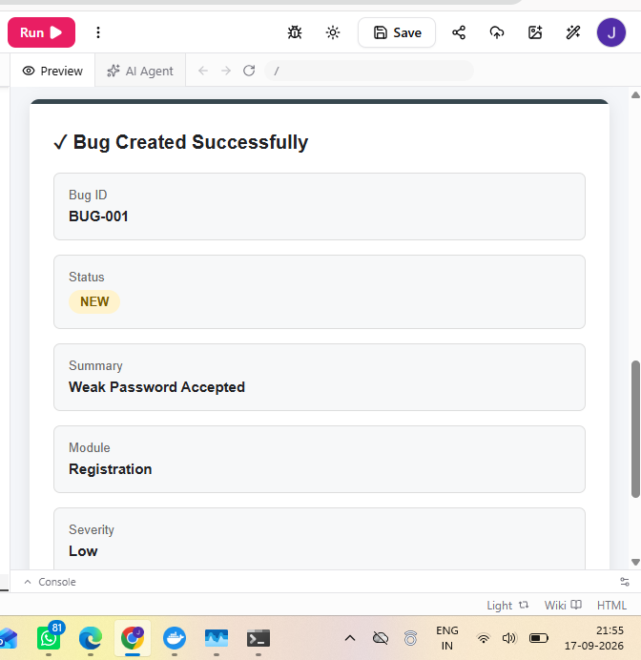
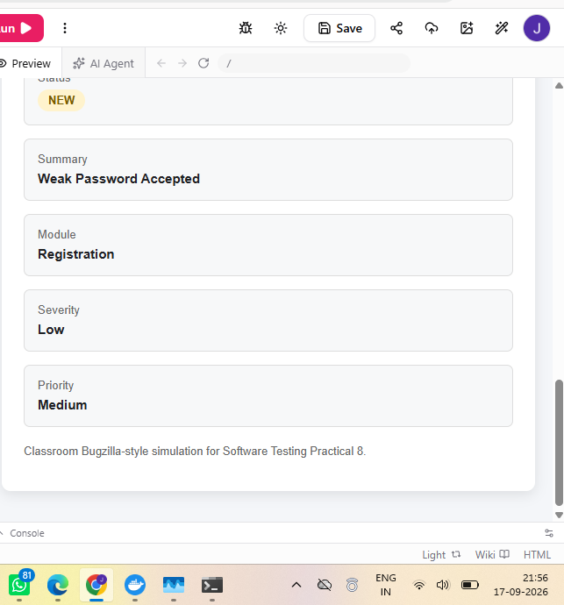
TC-010
Module: Bugzilla
Scenario: Set severity/priority
Test Steps: Open bug; set severity and priority; save.
Test Input: Medium / High
Expected Result: Values should be saved.
Actual Result: Severity Medium and Priority High saved.
Status: PASS
Comment: Classification verified.
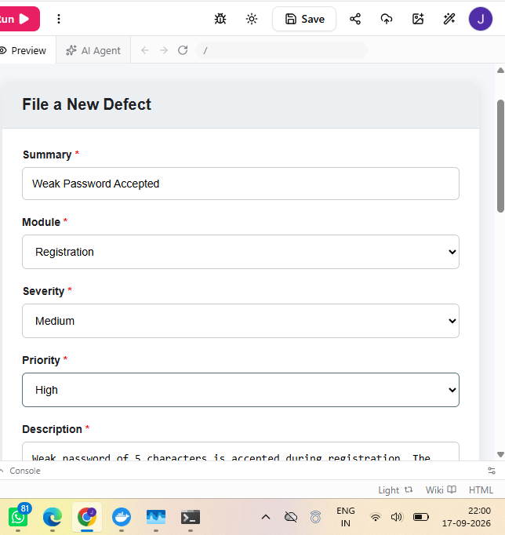
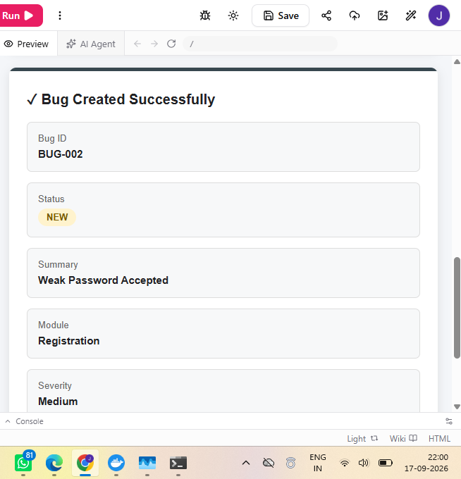
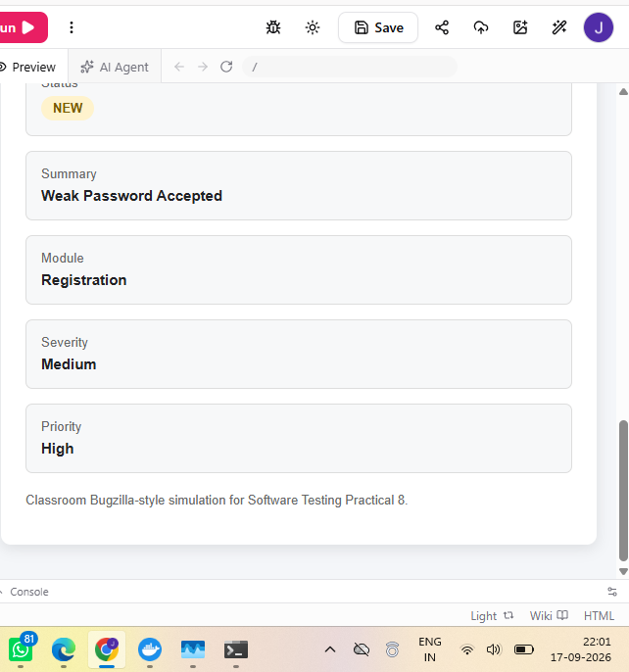

TC-011
Module: Bugzilla
Scenario: Update status
Test Steps: Open bug; change status; save.
Test Input: Open → In Progress
Expected Result: Status should update.
Actual Result: Bug status updated successfully.
Status: PASS
Comment: Status workflow verified.
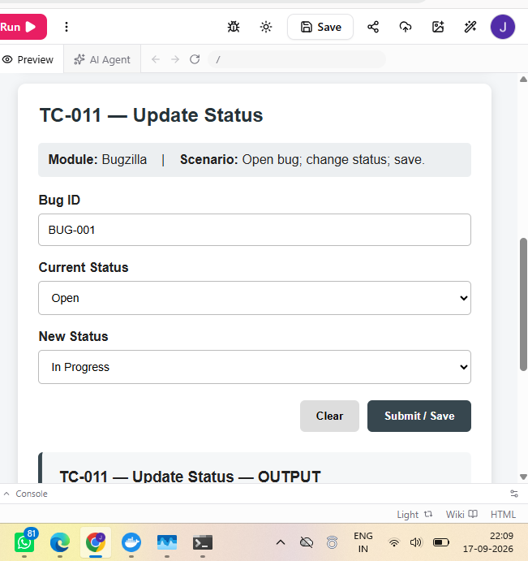
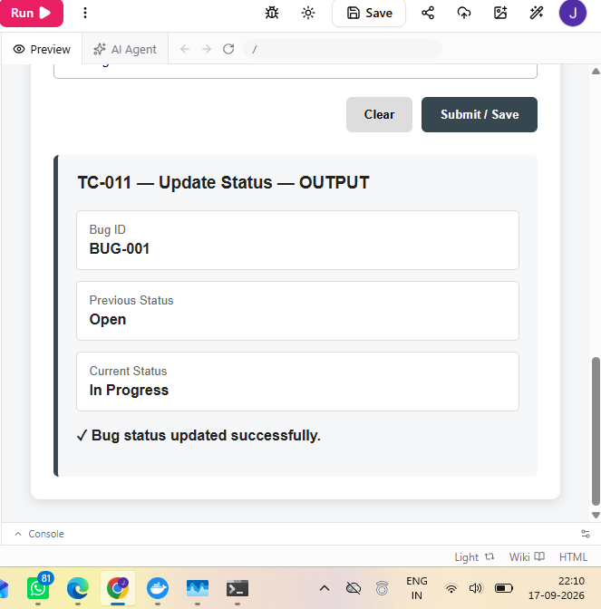
TC-012
Module: TestLink
Scenario: Create project
Test Steps: Log in; create project; enter details; save.
Test Input: Authentication Module
Expected Result: Project should be created.
Actual Result: Project created successfully.
Status: PASS
Comment: Project management.
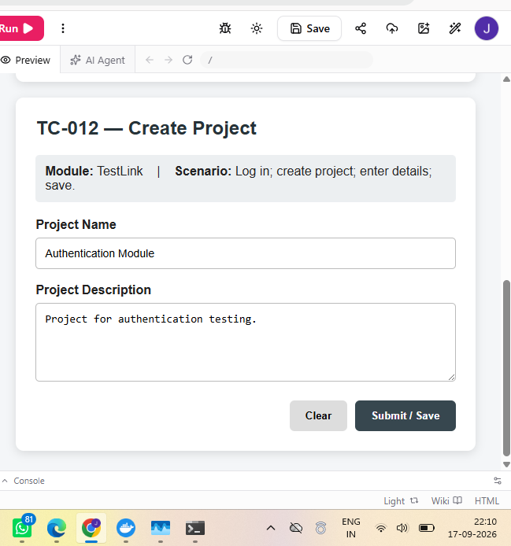

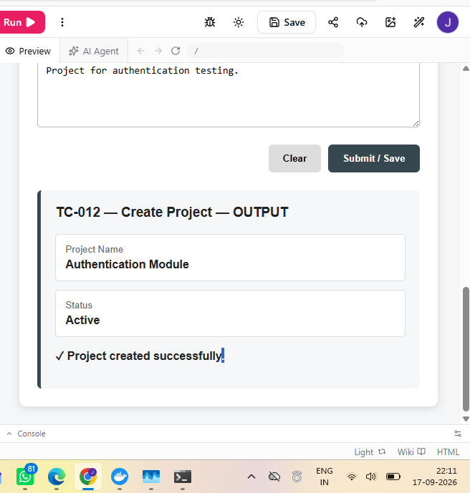

TC-013
Module: TestLink
Scenario: Create test suite
Test Steps: Open project; create suite; save.
Test Input: Login Test Suite
Expected Result: Suite should be created.
Actual Result: Test suite created successfully.
Status: PASS
Comment: Suite management.
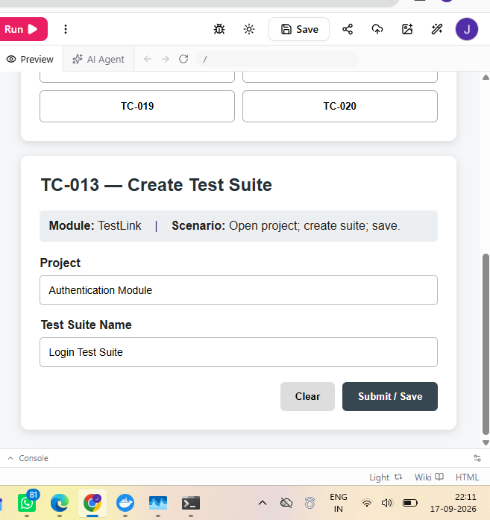
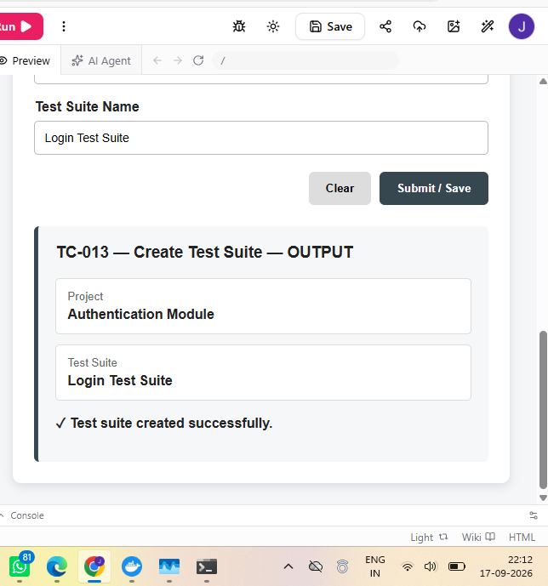
TC-014
Module: TestLink
Scenario: Create test case
Test Steps: Open suite; create case; enter steps/expected; save.
Test Input: Valid Login test case
Expected Result: Case should be saved.
Actual Result: Test case created successfully.
Status: PASS
Comment: Test case management.
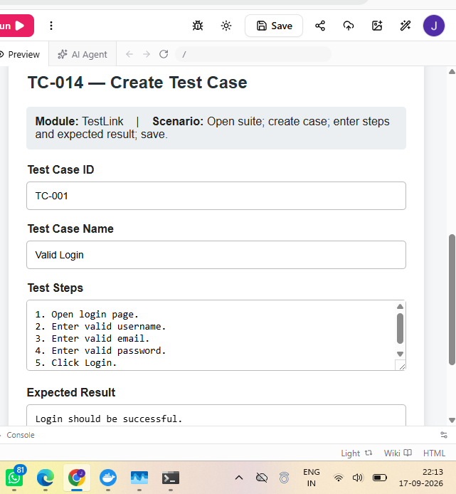
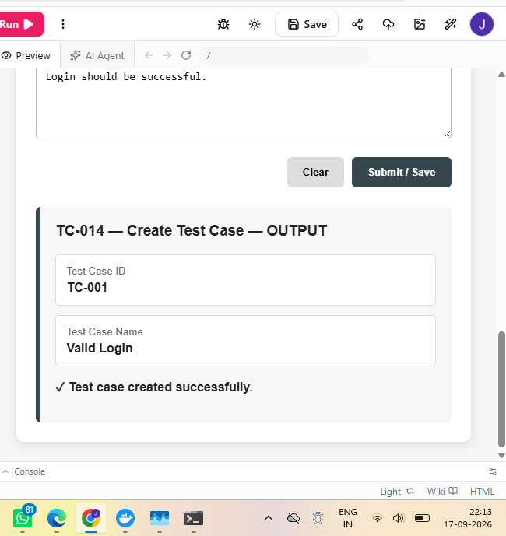

TC-015
Module: TestLink
Scenario: Execute PASS case
Test Steps: Open assigned case; execute; mark Pass; save.
Test Input: TC-001
Expected Result: PASS result should be recorded.
Actual Result: Execution result recorded as PASS.
Status: PASS
Comment: PASS execution workflow.
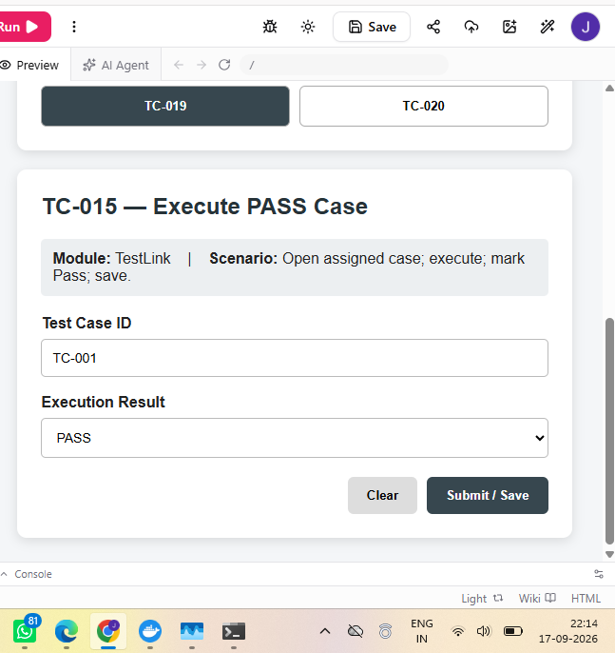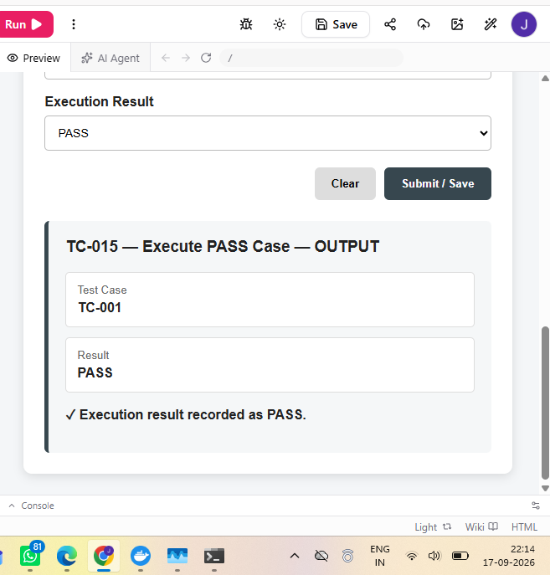

TC-016
Module: TestLink
Scenario: Execute FAIL case
Test Steps: Open case; execute; mark Failed; link defect; save.
Test Input: TC-004 / BUG-001
Expected Result: FAIL result and defect link should be recorded.
Actual Result: Execution result recorded as FAIL.
Status: PASS
Comment: Failure and defect linking.
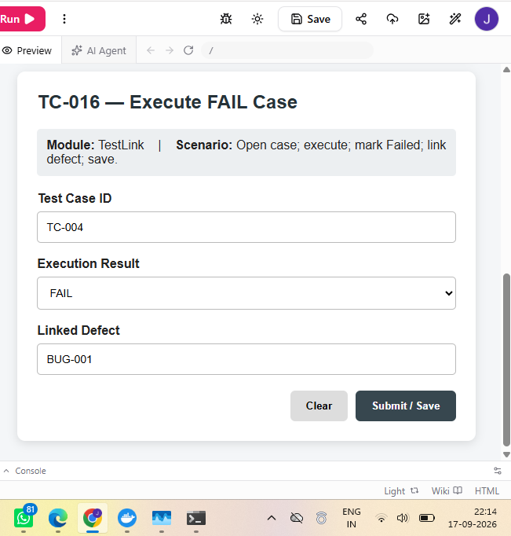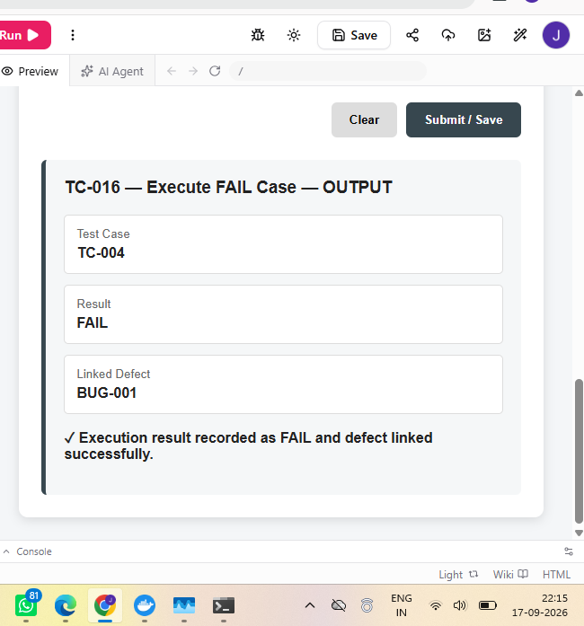

TC-017
Module: TestLink
Scenario: Generate execution report
Test Steps: Open reporting; select project/plan/build; generate.
Test Input: Authentication Test Plan
Expected Result: Report should show execution results.
Actual Result: Execution report generated successfully.
Status: PASS
Comment: Report generation.
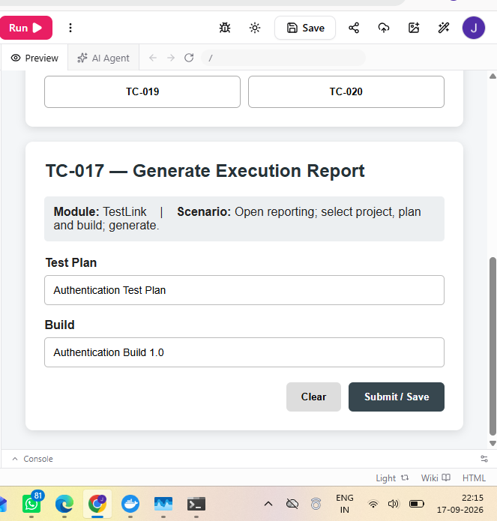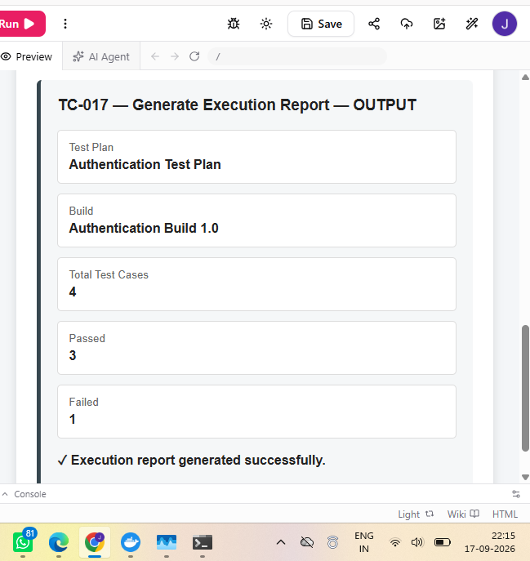

TC-018
Module: Bugzilla
Scenario: Search defect
Test Steps: Open Bugzilla; search by ID/summary.
Test Input: BUG-001
Expected Result: Matching defect should display.
Actual Result: BUG-001 displayed in search results.
Status: PASS
Comment: Defect search.
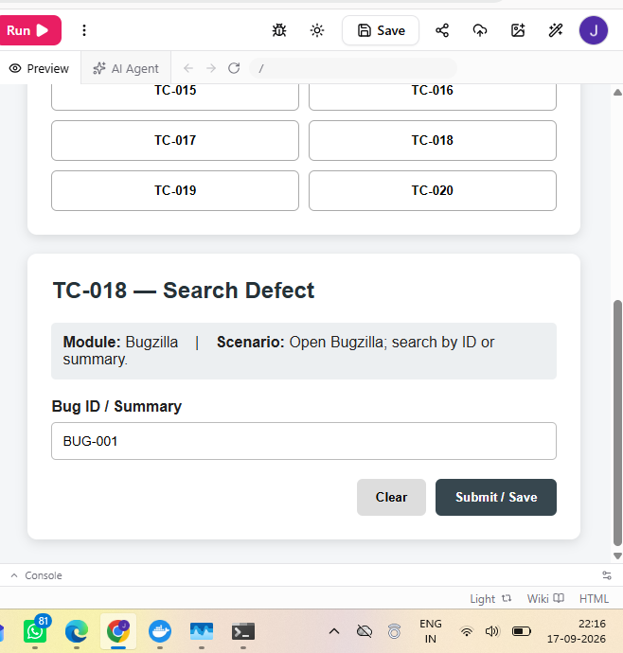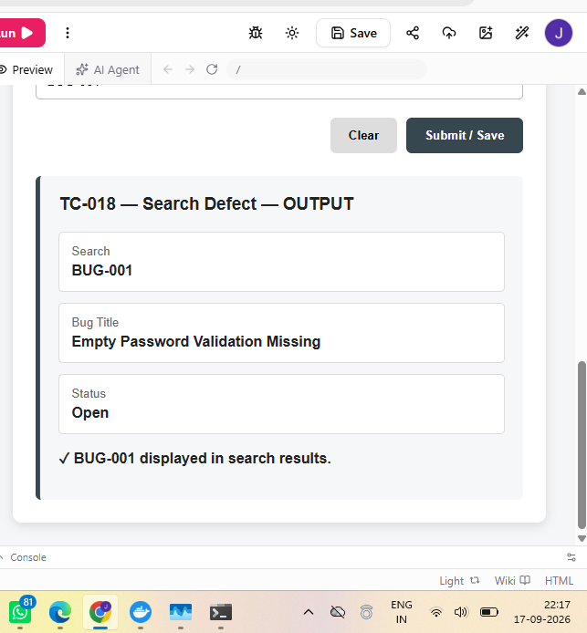

TC-019
Module: TestLink
Scenario: Requirement traceability
Test Steps: Open project; map requirement to case; save; view.
Test Input: User Authentication
Expected Result: Requirement-case mapping should display.
Actual Result: Requirement-test case mapping displayed.
Status: PASS
Comment: Traceability.
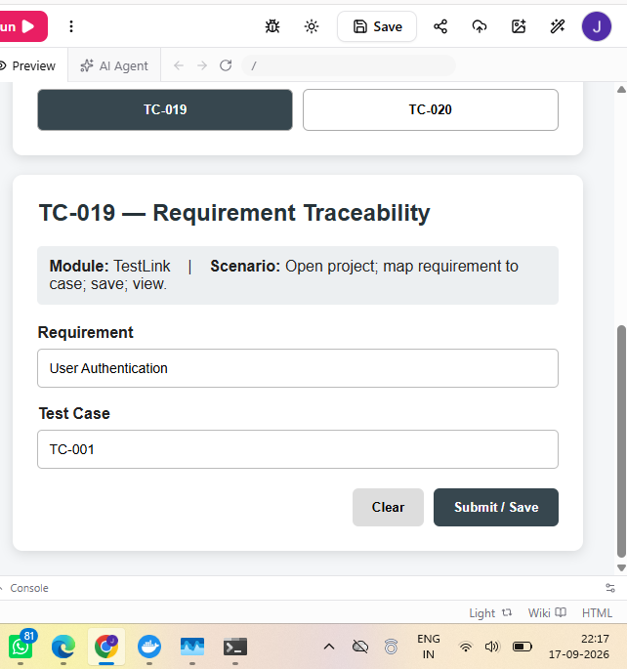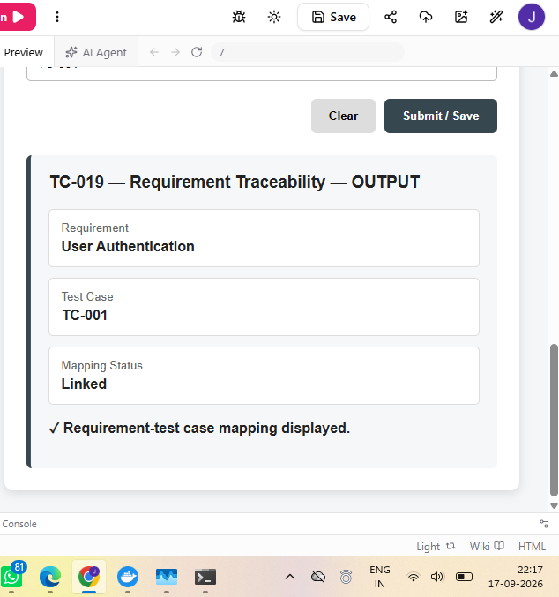

TC-020
Module: TestLink
Scenario: Build summary
Test Steps: Open execution page; select build; view summary.
Test Input: Authentication Build 1.0
Expected Result: Summary should show total/pass/fail.
Actual Result: Execution summary displayed successfully.
Status: PASS
Comment: Build summary.
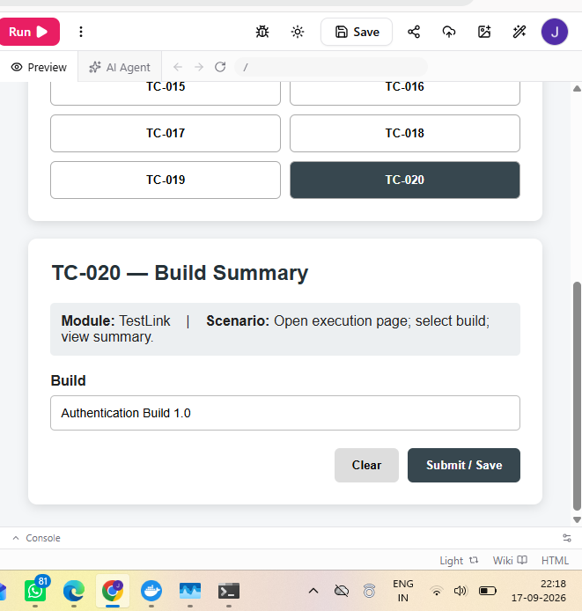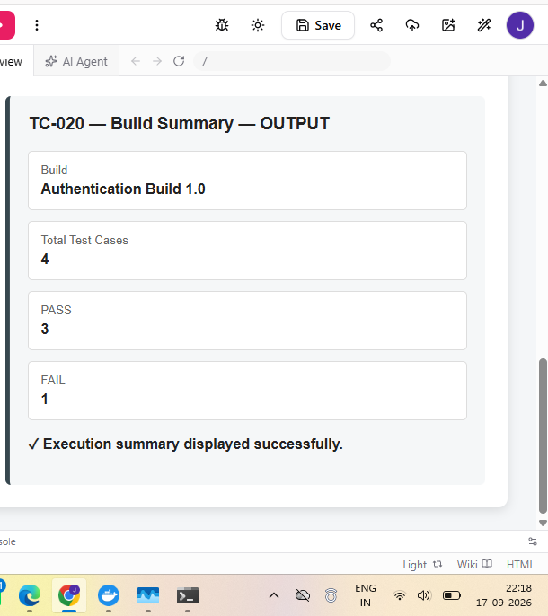

BUG IDENTIFICATION DETAILS

BUG-001
Bug ID: BUG-001
Defect Title: Empty Password Validation Missing
Module: Login Module
Severity: Medium
Priority: High
Status: Open
Defect Description: Blank password gives generic authentication error.
Steps to Reproduce: Open login; enter username janvi; leave password blank; click Login.
Expected Result: Password-required message should appear.
Actual Result: Invalid Username or Password.
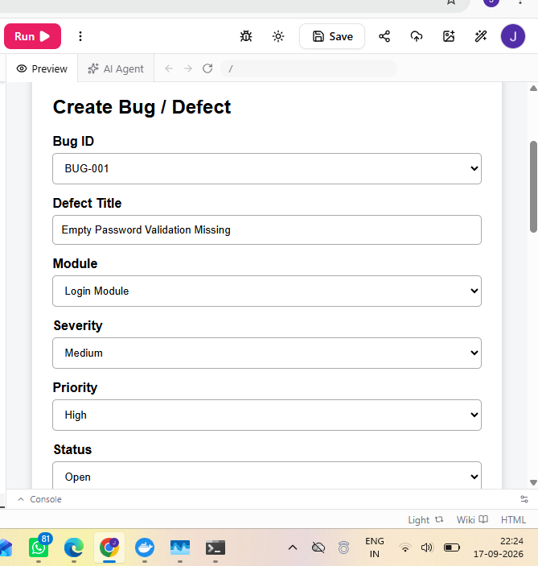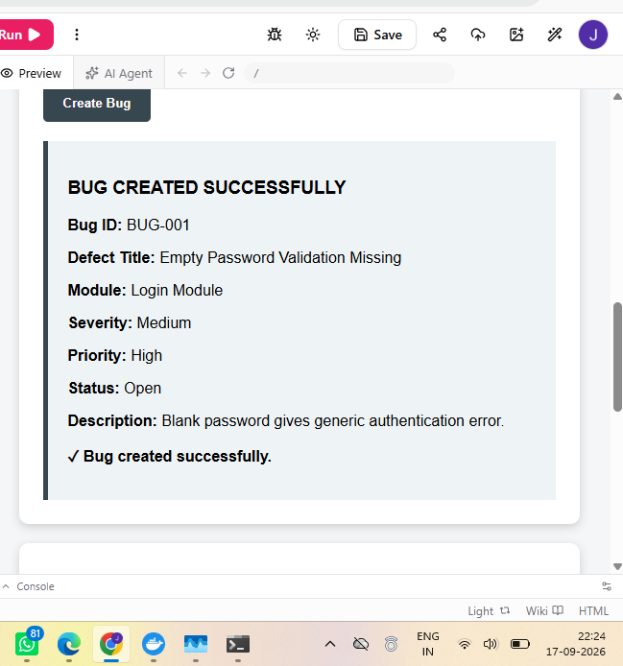
BUG-002
Bug ID: BUG-002
Defect Title: Weak Password Accepted
Module: Registration Module
Severity: Low
Priority: Medium
Status: Open
Defect Description: Weak password is accepted without strength validation.
Steps to Reproduce: Open registration; enter username/email; enter weak password; submit.
Expected Result: Weak password should be rejected.
Actual Result: Weak password is accepted.
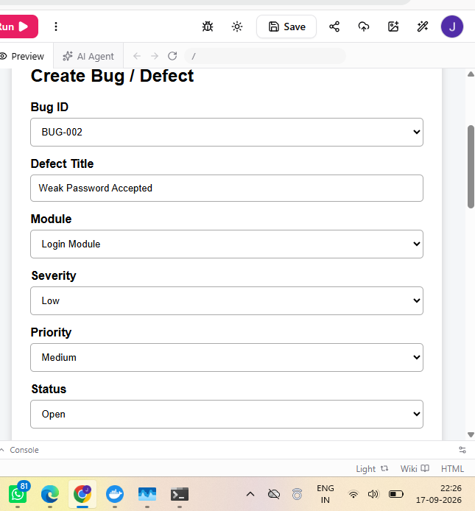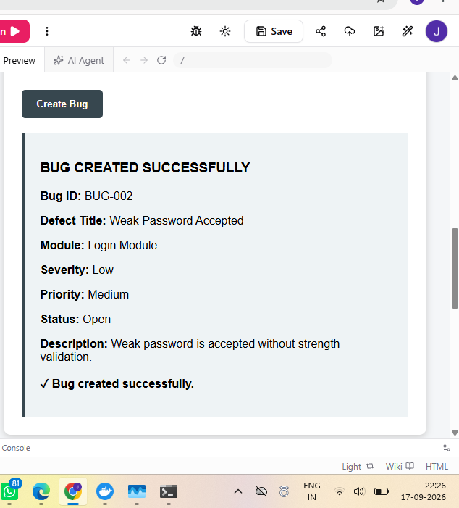
BUG-003
Bug ID: BUG-003
Defect Title: Payment Page Loads Slowly
Module: Payment Module
Severity: High
Priority: High
Status: In Progress
Defect Description: Payment page takes longer than expected.
Steps to Reproduce: Open payment; enter valid details; proceed; observe loading.
Expected Result: Page should respond within acceptable time.
Actual Result: Payment page responds slowly.
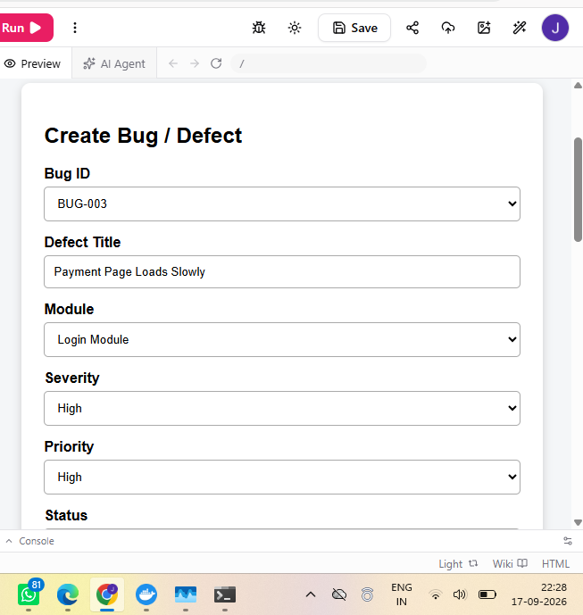
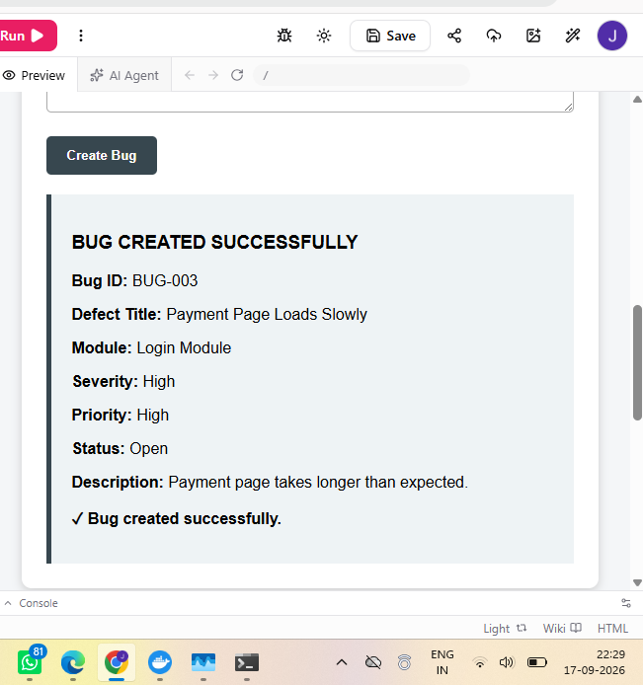
EXECUTION SUMMARY
Parameter | Result
Total Test Cases | 20
Passed | 16
Failed | 4
Pass Percentage | 80.00%
Overall Status | FAIL - Defects identified
OBSERVATION
- Bugzilla supports structured defect creation and tracking.
- TestLink supports test project, suite, case and execution management.
- PASS and FAIL results can be recorded after execution.
- Failed tests can be linked to defects.
- Execution reports provide a summary of testing results.
- Three example defects were identified and documented.
OUTPUT
Bug management, test case management, execution and reporting workflows were documented successfully. Defects were recorded with Bug IDs, severity, priority and status.
CONCLUSION
Thus, Bugzilla and TestLink workflows were applied for defect management, test case management, test execution and execution report generation. The practical demonstrates structured tracking of defects and test results.

